- Adtech Generated Email Modifications

- REQUIRED – Subject Line
  - If the file represents the Onyx incident update data set, the subject line should read “ResQ to Onyx Upload”
  - If the file represents the Oracle incident update data set, the subject line should read “ResQ to Oracle Upload”

- OPTIONAL – Subject Line
  - With the impending de-commission of ResQ, if you prefer to remove the “ResQ” reference in the subject line and replace it with something more relevant or generic, please communicate this to the Verint technical team, and we will adjust our code to accommodate.

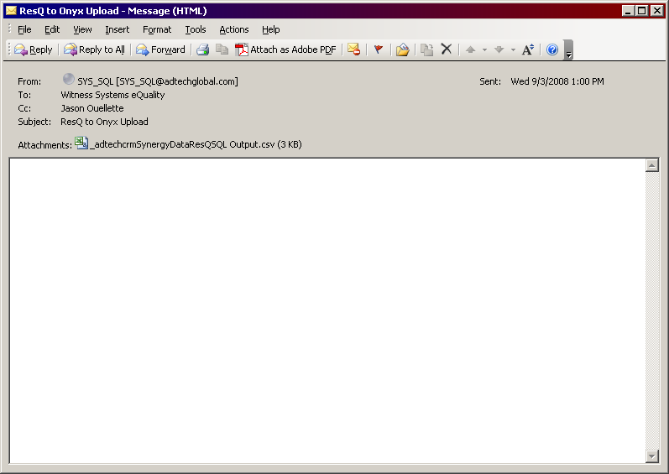

- Adtech Generated .CSV Modifications

- REQUIRED – Layout
  - A new column named “Status” will be added to the data file. Adtech will populate this with the Adtech incident status. If the value is “Closed”, the corresponding Onyx or Oracle incident will be marked as “Closed” automatically as a part of the processing of the update.

- OPTIONAL – File Name
  - The Adtech generated file is currently named _adtechcrmSynergyDataResQSQL Output.csv. With the impending de-commission of ResQ, if you prefer to remove the “ResQ” reference in the file name and replace it with something more relevant or generic, please communicate this to the Verint technical team, and we will adjust our code to accommodate.

- REQUIRED – File Name
  - The file name must be the same for both Oracle and Onyx data sets.

- REQUIRED – Data
  - A new field must be added to the Adtech CRM system to capture whether the incident originated in Onyx or Oracle (E.g.: “Verint Source System”)
  - All existing incidents in ResQ must be updated to have a “Verint Source System” identifier set to “Onyx”.
  - Upon creation of NEW support incident records, Adtech must maintain within their CRM system’s “Verint Source System” identifer whether the incident originated in “Oracle” or “Onyx”. This differentiator will be derived based on the email address the incident details was sent from. If the email address is onyxmail@witness.com, the value will be set to “Onyx”. If the email comes from prodwfmailer@verint.com, then it should be flagged as an “Oracle” incident the the Adtech CRM system.
  - A separate file for each “Oracle” and “Onyx” incident updates will be generated. Each will be emailed separately to the onyxmail@witness.com email address with the only differentiator being the subject line as specified in requirement I.1. above.

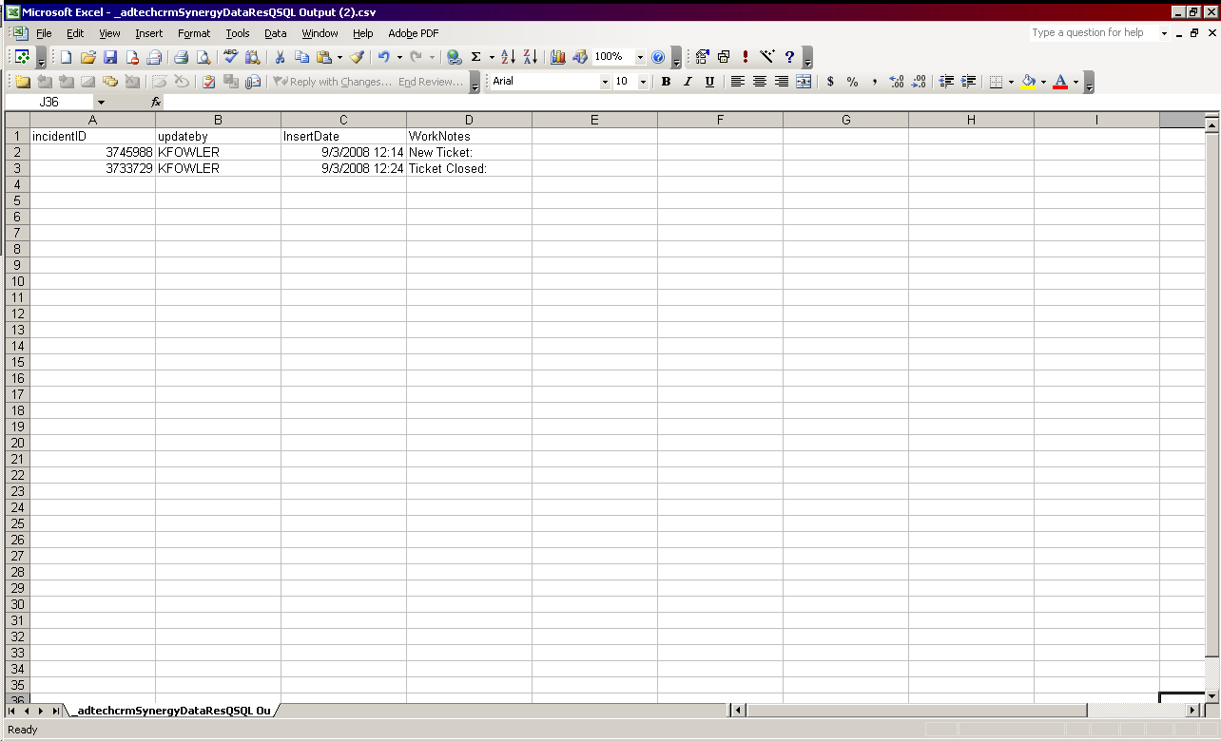

- Onyx Generated Emails

- The subject line for newly created Onyx incidents submitted to Adtech will change. Currently it reads “Witness New Customer Incident”. This will be changed to read “Verint New Customer Incident”

- There will be no changes to the email message body structure associated with newly created Onyx incidents sent to Adtech.

Sample Structure

Priority: 2 - High
Company Name: Automatic Data Processing, Inc. - Edgewood, NY
Onyx Customer Number: 204055
Onyx Incident Number: 3745964
Customer Primary Contact: Karen Luthy
Location: 50 Mercedes Dr, , Edgewood, New York, United States
Postal Code: 117178311
Incident Contact: Dawn Frazzitta
Business Phone: 6312541695
Cell Phone:
Fax:
Pager:
Email Address: dawn_frazzitta@adp.com
Support Level: Advantage
Incident Type: Software
Product: Compliance TDM Package
Version: OCT - 7.7
Serial Number:
Submitted By: Cesar Mendez
WorkNotes:

I changed the recording mode to Vox to see I the CS records on T1 trunk 1 & 2. Again, I see activity on channels from 121 to 143 only, which are T1 #3.

I don't see any DLIC Input disconnect in the CS front panel that tell us the T1 cables were un-attached to the card.

It seems there's an issue with DLIC card. ContactStore s/n 802067.

Transfering to Adtech.

- An “Update” email will be sent to Adtech whenever an Onyx support incident previously submitted to Adtech has a new work note added. The message body structure will be the same as the new incident message body structure. The subject line will read “Verint Updated Customer Incident”.

- The recipient email address will remain as it works today. If it’s an Americas support incident, it will route to Support@adtech.net. If it’s an EMEA or APAC incident, it will route to Emeasupport@adtech.net.

- Oracle Generated Emails

- The subject line for newly created Oracle incidents submitted to Adtech will read “Verint New Customer Incident”, just like the Onyx generated email.

- Email Message Body – TBD

- An “Update” email will be sent to Adtech whenever an Oracle service request previously submitted to Adtech has a new work note added. The message body structure will be the same as the new incident message body structure. The subject line will read “Verint Updated Customer Incident”.

- The recipient email address will remain as it works today. If it’s an Americas service request, it will route to Support@adtech.net. If it’s an EMEA or APAC service request, it will route to Emeasupport@adtech.net.

